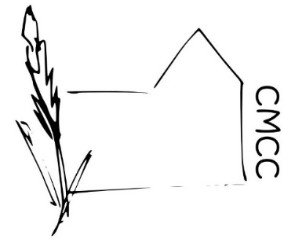

Chase Meadow Community Centre

HEALTH AND SAFETY POLICY / PROTOCOL

This document is for volunteers/employees/users and provides:

- A summary of Chase Meadow Community Centre’s (CMCC’s) responsibilities to the public and its policies with regard to Health and Safety
- Instructions /suggestions for employees/hirers/members of the public and volunteers for their own safety and well-being whilst in and when leaving the premises.

Awareness of needs of all users
- Be aware of any mobility, sight or sound impairment which a hirer/user/volunteer/employee may have, and take any appropriate measure(s) to ensure safety. For example, ensure that there are no obstructions in the path of people with impaired vision; ensure disabled access areas are left clear to ensure easy access.
- Ensure users of the centre are aware of the exits from CMCC in case of emergency and of any potential issues which routes may hold for people leaving the building in an emergency.
- Ensure all vulnerable persons are monitored and assisted with any emergency evacuation

Fire Safety
- All volunteers must know the location of fire extinguishers and the types of fire for which each may be used.
- In the event of a fire the priority should be on removing yourself from the premises and evacuating the building prior to calling the fire brigade.
- Regular fire inspections and drills are conducted.

First Aid
- First aid equipment is maintained in a clearly marked container in the kitchen of CMCC.
- All volunteers/employees should familiarise themselves with the location of this kit.
- CMCC has no legal duty to administer first aid to the public and, indeed, only those who are trained to do so should attempt to render assistance
- Do not administer medicines e.g. aspirin or paracetamol.

Accident Book
- An accident book is located in the kitchen, near the first aid kit (this is not a legal requirement).
- Record all incidents which require any medical attention, with brief details of the nature and cause of the injury and the name and address of the injured party.

Personal safety
- A minimum of two adults should be present whenever CMCC is open to the public. An exception to this would be, for example, when an authorised key holder is in the process of opening or closing the building.
- Always consider your personal safety if someone becomes challenging and never use physical restraint. Where necessary obtain help and assistance from another adult as soon as possible. Consider recording any challenging incidents.

Equipment
- All volunteers should familiarise themselves with the equipment such as computers, photocopiers, telephones, kitchen equipment, light and sound systems so they can use them safely if and when necessary.
- Anyone using computer screens on a regular basis should move away from them at regular intervals to ensure their eyes get a rest period and there are not long periods of remaining seated.
- Care should be taken when using and moving equipment to ensure they are handled, moved and used correctly to minimise the risk of injury.

Children
- Parents must accept responsibility for the safety and care of their children at all times in the centre to include use of all areas and play/sports equipment.

Hazards
- Equipment – Staff should immediately turn off, remove and/or label as ‘out of order’ any equipment that seems dangerous or faulty and report this to the Management Committee.
- Slips, trips and falls – are the most common accidents, so do all you can to ensure boxes and other trip hazards are removed.
- Substances- there should be no hazardous substances kept on CMCC premises other than labelled cleaning products.

Reporting

Staff and volunteers/employees should report any Health and Safety concerns to the Management Committee at the earliest available opportunity. Health and safety will be an agenda item at Committee meetings.

Approved by ………………………………….(Ms Helen Venn) on behalf of the CMCC Management Committee.

Dated…………… February 2019

