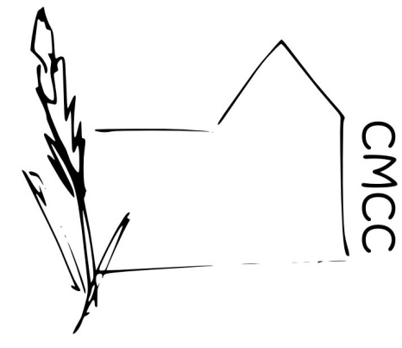

Chase Meadow Community Centre

E-SAFETY POLICY
Electronic media and devices including PC’s, tablets, laptops, mobile phones, webcams etc create an additional risk on our children.
Internet chat rooms, discussion forums or social networks and applications can all be used as a means of contacting children and young people with a view to grooming them for inappropriate or abusive relationships. They can also be used for the provision of inappropriate content. The anonymity of the internet can allow adults to pretend to be children and have conversations with children and in some cases, arrange to meet them. The internet is also a tool in the distribution of indecent photographs of children. Users can engage in or be a target of cyberbullying using a range of methods including text and instant messaging to reach their target. Mobile phones are also used to capture violent assaults of other children for circulation (happy slapping), or distributing indecent images of children (e.g. sexting).
The best protection is to make users aware of the dangers. As third parties run the majority of services and groups in the centre, we ask each of our user groups to provide their own safeguarding policy, following best practice guidelines.
See also the Child & Vulnerable Adult Protection Policy
We ask any group using the centre to remember that protection is prevention and to this end:
- Controls are in place to minimise access and to highlight anyone accessing inappropriate sites or information both for public computers and the centre network.
- Note we can obtain details of people accessing the WIFI
- Staff and volunteers should not give out their personal details, phone numbers, home address, computer passwords etc.
- The police will be involved if there is any criminal element to misuse of the internet, phones or any other form of electronic media.

Approved by ………………………………….(Ms Helen Venn) on behalf of the CMCC Management Committee.

Dated…………… February 2019

