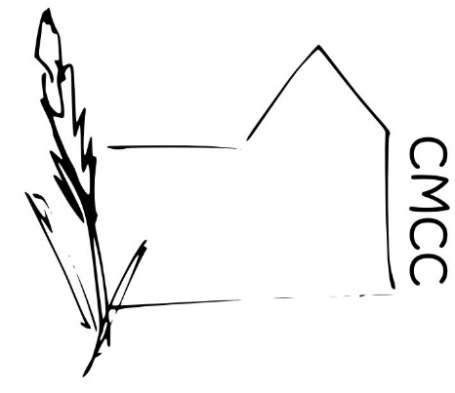

Chase Meadow Community Centre (CMCC)

EQUAL OPPORTUNITIES POLICY

CMCC will comply with current legislation to provide equal opportunities for users, officers, volunteers and employees. We will act positively to treat all members fairly, avoiding discrimination on the grounds of race, creed, language, disability, age and gender.

Sensitivity to equal opportunities will be encouraged among Directors, Trustees, volunteers and employees.

For information, the protected characteristics are:

- Age
- Disability
- Gender reassignment
- Marriage and civil partnership
- Pregnancy and maternity
- Race
- Religion and belief
- Sex

Approved by ………………………………….(Ms Helen Venn) on behalf of the CMCC Management Committee.

Dated…………… February 2019

