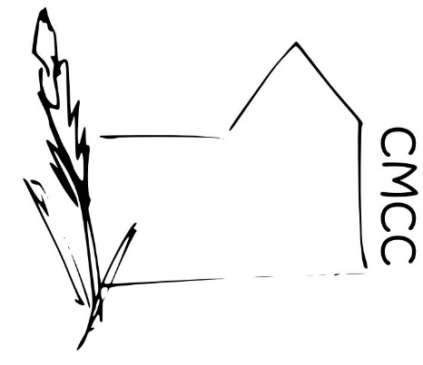

Chase Meadow Community Centre

ENVIRONMENTAL POLICY

Mission Statement
The Chase Meadow Community Centre (CMCC) management committee recognises that it has a responsibility to the Community, the Centre and its environment beyond normal legal and regulatory requirements. We are therefore committed to reducing our environmental impact and continually improving our environmental performance as an integral part of our operating methods wherever possible. The below sets out what we endeavour to do at CMCC.

General Policy Aims
- Comply with all relevant regulatory environmental requirements.
- Look to improve and reduce our environmental impact.
- Minimise the amount of waste we generate and promote re-use recycling and composting wherever possible
- Use local labour and materials where available to reduce C0₂ and help the community.
- Improve and increase volunteer and/or employee awareness in terms of the local environment.

Energy and Water
- Reduce the amount of energy used by switching off lights and electrical equipment when not in use.
- Adjust the heating with energy consumption in mind.
- Check for and rectify any dripping taps or pipes.
- Evaluate the energy consumption and efficiency of new equipment when purchasing.

Paper and office supplies
- Minimise the use of paper in the office and reuse and recycle all paper where possible.
- Reduce packaging as much as possible.

Transportation
- Reduce the need to travel by car and encourage volunteers/staff/users to walk, cycle or to share lifts wherever possible.
Maintenance and Cleaning
- Cleaning materials will be as environmentally friendly as possible.
- Materials used in any refurbishment will be as environmentally friendly as possible.
- We will only use licensed and appropriate organisations to dispose of waste.

Approved by ………………………………….(Ms Helen Venn) on behalf of the CMCC Management Committee.

Dated…………… February 2019

