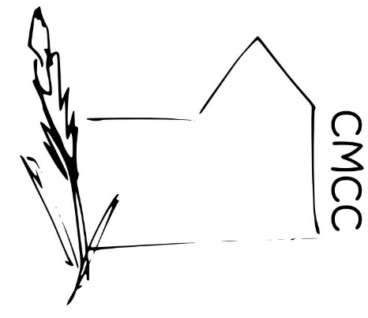

Chase Meadow Community Centre

INTERNAL POLICY

Dealing with the public

- When representing Chase Meadow Community Centre (CMCC) volunteers/employees should identify themselves.

- Be mindful of your own personal safety and make yourself aware of the current alarm precautions available via the Intruder Alarm System operating in the centre.

- A minimum of two adults should be present whenever CMCC is open to the public. An exception to this would be, for example, when an authorised key holder is in the process of opening or closing the building.

- Treat people with respect, courtesy and consideration and be as helpful as possible and mindful of employees/volunteers/hirers/user and individuals’ needs as CMCC is providing a service to the community.

- Ensure that confidential information discussed in CMCC remains confidential. Offer use of a confidential interview room if necessary (see Confidentiality Policy).

- Ensure messages are passed on to the correct people accurately and quickly as possible.

- Hirers rates allow a discount for charitable organisations and any other discounted rates or free trial periods should be agreed by the Management Committee taking into account the financial position of the potential hirer and the people the service is aimed at in conjunction with consideration of CMCC Ltds charitable objectives. This policy does not extend to CMCC Ltd making charitable donations.

- Management Committee decisions in relation to the acceptance or termination of hirers agreements is final.

- In the event of user(s) displaying antisocial/aggressive/inappropriate behaviours, Management Committee decisions in relation to requiring people to leave and/or not to enter the centre is final.

Volunteer/employee responsibility

- When attending the centre volunteers/employees should check any post or messages are received and dealt with and new posters are placed onto notice boards as soon as possible.

- Encourage opportunities to promote and develop CMCC as a service provider and base for information.

The building

- Ensure CMCC is clean, tidy and fit for use by hirers.

- No cash (other than petty cash) or valuables should be left on the premises overnight.

- Personal possessions/equipment/resources/valuables are brought into the building entirely at owners risk.

- No material deemed in anyway offensive by CMCC Management Committee/Officers should be displayed.

- No trade advertisements or trade signs to be displayed without permission from CMCC Management Committee.

- No party political materials to be left or displayed at CMCC other than contact details of local elected members. There may be an exception with the Management Committee’s discretion such as use of the building as a polling station.

- Ensure the heating is turned down or off, the lights are switched off and internal doors/windows are shut and locked as appropriate.

- Users will take responsibility for opening and locking the centre and all users should be familiar with the alarm system. Sets of keys will be numbered and a record of key holders and key numbers and alarm numbers is kept with the CMCC records.

- Tea, coffee and milk can be purchased for use by volunteers/employees/users, for a contribution in the honesty box.

- Alcohol should be used on the premises only with the appropriate permissions and licences.

- Petty cash is held for stationery, cleaning items, consumables and other small purchases. Volunteers/employees should buy items; retain the receipt and a record the purchase on the petty cash sheet.

Information and publicity

- Internal and external CMCC Notice boards, information and leaflets should be regularly updated.

Volunteers

- There may be occasions when the Management Committee decides to give a gift to a volunteer/employee in recognition of a particular piece of work.

Approved by ………………………………….(Ms Helen Venn) on behalf of the CMCC Management Committee.

Dated…………… February 2019

