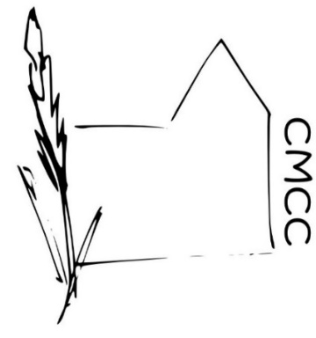

Chase Meadow Community Centre

TELEPHONE POLICY

Use of the Telephone is limited to
- Any Chase Meadow Community Centre (CMCC) Committee member to make centre related calls.
- Any Centre user in an emergency (i.e. emergency services or to contact a family member).
- Any Local Authority and/or Police Officers and PCSOs to make community-based calls.
- The telephone should be only used for official calls not for personal or private calls. If there appears to be excessive unauthorised use an itemised telephone accounts checks may prove necessary to identify the caller and request payment.

When Answering the Telephone
- Give clear details to the caller. For example, “Hello - Chase Meadow Community Centre – xxxxx speaking” and at the end of the call thank the person for calling.
- If you are unable to deal directly with the callers’ request take sufficient details (name, phone number/s, email contact, details of request etc) and let the caller know that it will be dealt with. Make certain that the person who can deal with the issue knows about the call and will respond.
- It is anticipated that most communications will be via email so gaining an email contact (and giving chasemeadowcentre@gmail.com) address may prove beneficial.

Use of the Answer phone
- Listen to any messages as soon as convenient and list any messages in the messages book.
- Deal with the call yourself if possible. Otherwise make sure it is dealt with by the most appropriate person.
- Ring the caller back and let them know the outcome of their call

The reputation and efficiency (or otherwise) of the centre is judged by others on the reception they receive either when using the community centre in person or telephoning/emailing and so please be courteous at all times.

Approved by ………………………………….(Ms Helen Venn) on behalf of the CMCC Management Committee.

Dated…………… February 2019

